A000-Afr-Aterian Tanged Points-North Africa-Magreb Region-Middle Stone Age -100-30 kya.

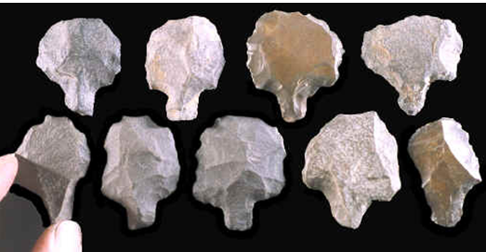

Fig. 1. Aterian Tanged Points-North Africa-Magreb Region-Middle Stone Age -100-30 kya.

**Case No.: Projectile Points**

**Accession No.:**

**Formal Label:** Aterian Tanged Points-North Africa-Magreb Region-Middle Stone Age -100-30 kya.

**Display Description:**

Aterian may be termed a Middle Paleolithic or Late Pleistocene flake-oriented technocomplex with a huge geographic area extending across North Africa and is defined by tanged lithics with similarities to Mousterian use of Le­vallois technique and some formal tools, resembling Upper Paleolithic technology, and, hence, is similarities to the Mousterian tradition, particularly for the presence of Le­vallois technique and a marked evolution of some formal tools, which re­semble elements of Upper Paleolithic technology, and, hence, is generally believed to have developed from of the Middle Paleolithic-Middle Stone Age (MP-MSA) ‘‘Mousterian’’ (e.g., Hahn 1984; Wengler 1997). The phenomenon of tanged lithic artifacts can be found in MP-MSA contexts on the Arabian Peninsula (McClure 1994). With regard to the central Sahara, the Aterian technocomplex is key for relationship to the Mousterian and to the dispersion of Homo sapiens from the Nile Valley, to the eastern Sa­hara, and to the Maghreb in the MP-MSA /Upper Paleolithic transition. The following Aterian dates suggest this **west to east flow of Aterian culture**:

103±3 ka (mean OSL) La Grotte des Contrebandiers on the Atlantic coast of Morocco with Moroccan Mousterian 116 3± ka with a hiatus of up to 13 ±3 ka. -Rabat-Moroco Barton-l-2009-OSL-dating-Dar-es-Soltan-I

47,000 ± 3200: Haua Fteah, a karstic cave in Cyrenaica, Libya,

Taforalt >40,000 (or Grotte des Pigeons), a cave located in the northern Oujda region of Morocco,

>39,900: Wadi Saoura, in southwestern Algeria,

>35,000 Bir el Ater, in far eastern Algeria the type site of the MP-MSA Aterian,

The Aterian techno-complex extends both time-wise for 70,000 years and aerially for 2,500 km (1,600 mi) from the Maghreb of Morocco (where it is post-Mousterian, ca 100 kya) to the Western Desert of Egypt and the Nile valley (where it is post Levallois, ca 30 kya). It is distinguished by tanged implements designed for hafting with a wooden shaft. This produced a composite tool used for knives and scrapers rather than for projectile points. The Aterian complex extends (Tixier, 1967; Petit-Maire, 1982; Wendorf and Schild, 1992).

**LC Classification:** GN775

**Date or Time Horizon:** 100-30 kya

**Geographical Area:** Maghreb region of North Africa

Map:



Map of Aterian sites (red circles). Base map from NASA http://www2.jpl.nasa.gov/srtm/africa.htm.

doi:10.1371/journal.pone.0029029.g002

**Cultural Affiliation:** Aterian

**Medium:** Flint, Silicified sandstone

**Dimensions:** H 1-3 in

**Weight: varies**

**Provenance:** Morocco

**Condition:** Original

**Discussion:**

Aterian tanged tool hafting occurred in the Maghreb among anatomically modern humans. One question arises: “What occasioned the invention of hafting?” In the Maghreb at ca 100,000 BP, resin–bearing trees became scarce, so hafting with a leather thong around a tang became more feasible than hafting with resin using a non-tanged lithic (see Ferring, 1975). Furthermore, these tanged tools were not used for war or hunting but for agriculture as a spade and wood-working as a chisel. Therefore, the Aterian culture was peaceful and agrarian during the Middle Paleolithic. However, there are few sites during this time-horizon in the Maghreb region of North Africa with a long stratigraphy and reliable C14 dates. One exception is the Rhafas Cave in Eastern Morocco, which has dates spanning the time horizon from >100,000 BP to 80,000 BP, and it is within this framework that the Aterian occurs (Mercier *et alii* 2007).

Sites Age BP Lab. No. Reference

|  |  |  |  |
| --- | --- | --- | --- |
| Grotte des Contrebandiers | 103±3 ka OOOSL(OSL) |  | Jacobs et al. 2011 |
| Grotte des Contrebandiers | 24,500 ± 600 | Gif-2582 | Delibrias *et al.* (1982) |
| Grotte des Contrebandiers | 23,700 ± 1000 | Gif-2585 | Delibrias *et al.* (1982) |
| Dar es Soltan | >27,000 | UCLA-678B | Ruhlmann (1951) |
| Dar es Soltan | >30,000 | UCLA-878A | Roche (1956) |
| Taforalt (layer 18) | >32,370 +2470/-1890 | Gif-2276 | Debenath (1992) |
| Taforalt (layer 19) | >34,550 +3200/-2280 | Gif-2277 | Debenath (1992) |
| Taforalt (base layer 19) | >40,000 | G if-2588 | Debenath (1992) |
| Taforalt (top layer 19) | >40,000 | Gif-2589 | Debenath (1992) |
| Taforalt (layer 23) | >40,000 | Gif-2279 | Debenath (1992) |
| Bir el Ater | >35,000 | MC-657 | Close (1980) |
| Wadi Saoura | >39,900 | 1-1787 | Chavaillon (1964) |
| Haua Fteah | 47,000 ± 3200 | GrN-2023 | McBurney (1967) |

|  |  |  |  |
| --- | --- | --- | --- |
|  |  |  |  |
| Grotte des Contrebandiers | 103±3 ka OOOSL(OSL) |  | Jacobs et al. 2011 |
| Grotte des Contrebandiers | 24,500 ± 600 | Gif-2582 | Delibrias *et al.* (1982) |
| Grotte des Contrebandiers | 23,700 ± 1000 | Gif-2585 | Delibrias *et al.* (1982) |
| Dar es Soltan | >27,000 | UCLA-678B | Ruhlmann (1951) |
| Dar es Soltan | >30,000 | UCLA-878A | Roche (1956) |
| Taforalt (layer 18) | >32,370 +2470/-1890 | Gif-2276 | Debenath (1992) |
| Taforalt (layer 19) | >34,550 +3200/-2280 | Gif-2277 | Debenath (1992) |
| Taforalt (base layer 19) | >40,000 | G if-2588 | Debenath (1992) |
| Taforalt (top layer 19) | >40,000 | Gif-2589 | Debenath (1992) |
| Taforalt (layer 23) | >40,000 | Gif-2279 | Debenath (1992) |
| Bir el Ater | >35,000 | MC-657 | Close (1980) |
| Wadi Saoura | >39,900 | 1-1787 | Chavaillon (1964) |
| Haua Fteah | 47,000 ± 3200 | GrN-2023 | McBurney (1967) |

The evidence for an early invention and increasing prevalence of hafted tools is mounting, both in Europe, among Neandertals (e.g., [71,72]) and in Africa, among anatomically modern humans ([73,74]). In light of this evidence, it is perhaps more appropriate to treat the ‘Aterian question’ in terms of an early innovation in hafting, rather than in projectile use, or, indeed, in weapon use at all. And if that is the case, we must ask what prompted the invention of the hafting insert. It could be speculated that the invention of this distinguishing feature of the Aterian, the tang, was associated with a move into increasingly arid zones of the Sahara [19,20,75], where the lack of resin-bearing trees could have created the need for a hafting insert adapted for use with bindings (but see [73] for evidence of an increase in the use of resin for hafting in southern Egypt in the Upper Pleistocene and [76,77] for an ethnographic account of spear-hafting using resin in the Australian desert). It is as yet unclear if gum-yielding plants would have been available in the more arid zones of North Africa 100 thousand years ago, but it makes sense that a tang allows for an easier hafting using leather bindings, since it provides a less sharp and more regular surface to wrap around. The Aterian culture is found across North Africa (see Map) and is differentiated from the Mousterian and essentially defined by the presence of these tanged (stemmed) tools.

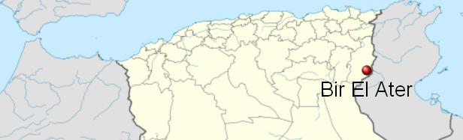

>30,000 Dar es Soltan the type site of the last 'glacial' period known as the Soltanian (Choubert, 1953; Choubert et al., 1956) a low calcarenite cliff on the Atlantic coast of Morocco near Rabat (33°58′44″N, 6°53′51″W)

.

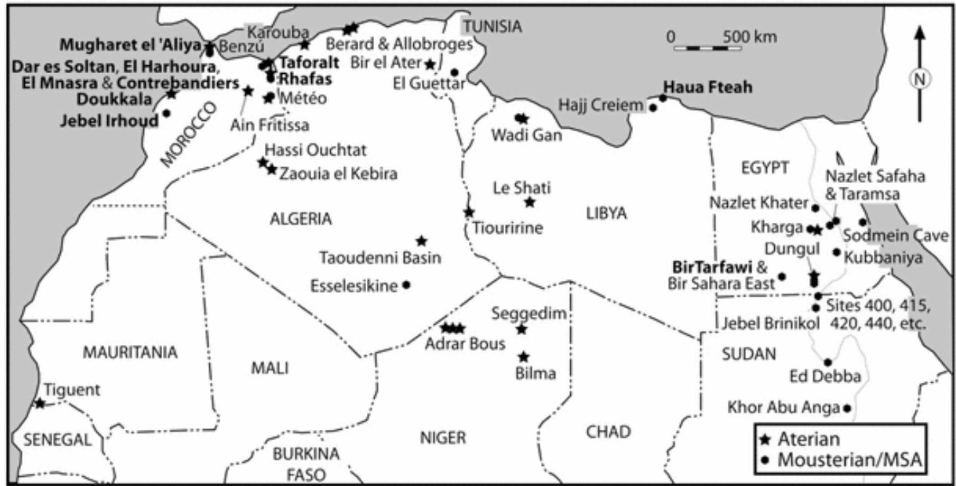

From Steele 2012.

Radiocarbon Dates of Aterian Sites in North Africa

Sites Age BP Lab. No. Reference

.

|  |  |  |  |
| --- | --- | --- | --- |
| Grotte des Contrebandiers | 103±3 ka OOOSL(OSL) |  |  |
| Grotte des Contrebandiers | 24,500 ± 600 | Gif-2582 | Delibrias *et al.* (1982) |
| Grotte des Contrebandiers | 23,700 ± 1000 | Gif-2585 | Delibrias *et al.* (1982) |
| Dar es Soltan | >27,000 | UCLA-678B | Ruhlmann (1951) |
| Dar es Soltan | >30,000 | UCLA-878A | Roche (1956) |
| Taforalt (layer 18) | >32,370 +2470/-1890 | Gif-2276 | Debenath (1992) |
| Taforalt (layer 19) | >34,550 +3200/-2280 | Gif-2277 | Debenath (1992) |
| Taforalt (base layer 19) | >40,000 | G if-2588 | Debenath (1992) |
| Taforalt (top layer 19) | >40,000 | Gif-2589 | Debenath (1992) |
| Taforalt (layer 23) | >40,000 | Gif-2279 | Debenath (1992) |
| Bir el Ater | >35,000 | MC-657 | Close (1980) |
| Wadi Saoura | >39,900 | 1-1787 | Chavaillon (1964) |
| Haua Fteah | 47,000 ± 3200 | GrN-2023 | McBurney (1967) |

McClure, H. A. (1994). A new Arabian stone tool assemblage and

notes on the Aterian industry of North Africa. Arabian Archaeology

and Epigraphy, 5, 1–16.

**References:**

Function. PLoS ONE 6(12): e29029. doi:10.1371/journal.pone.0029029

Ferring, C.R., 1975. The Aterian in north African prehistory. *Problems in prehistory: North Africa and the Levant*, pp.113-126.

Iovita R (2011) Shape Variation in Aterian Tanged Tools and the Origins of Projectile Technology: A Morphometric Perspective on Stone Tool

Mercier, N, L. Wengler, H. Valladas, J.-L. Joron, L. Froget, J.-L. Reyss. 2007. The Rhafas Cave (Morocco): Chronology of the Mousterian and Aterian archaeological occupations and their implications for Quaternary geochronology based on luminescence (TL/OSL) age determinations, [*Quaternary Geochronology*](http://www.sciencedirect.com/science/journal/18711014), 2:4, 309-313.

Petit-Maire, N. ed., 1982. *Le Shati: Lac pléistocene du Fezzan (Libye)*. CNRS.

Steele, T. E. 2012. “Late Pleistocene Human Subsistence in Northern Africa. TRhe State of our knowledge and placement in a continental context.” In Jean-Jacques Hublin and Shannon T. McPherron. *[Modern Origins: A North African Perspective (Vertebrate Paleobiology and Paleoanthropology).](https://www.amazon.com/Modern-Origins-Perspective-Paleobiology-Paleoanthropology/dp/9400729286/ref=sr_1_1?s=books&ie=UTF8&qid=1534338847&sr=1-1" \o "Modern Origins: A North African Perspective (Vertebrate Paleobiology and Paleoanthropology))*[New York: Springer.](https://www.amazon.com/Modern-Origins-Perspective-Paleobiology-Paleoanthropology/dp/9400729286/ref=sr_1_1?s=books&ie=UTF8&qid=1534338847&sr=1-1" \o "Modern Origins: A North African Perspective (Vertebrate Paleobiology and Paleoanthropology))

Tixier, J., 1967. *Procédés d'analyse et questions de terminologie concernant l'étude des ensembles industriels du Paléolothique récent et de l'Epipaléolithique dans l'Afrique du nord-ouest*. University of Chicago Press.

Wendorf, F. and Schild, R., 1992. “The Middle Paleolithic of North Africa: a status report,” *New light on the Northeast African past*, pp.40-78.

Steele, T. E. 2012. “Late Pleistocene Human Subsistence in Northern Africa. TRhe State of our knowledge and placement in a continental context.” In Jean-Jacques Hublin and Shannon T. McPherron. *[Modern Origins: A North African Perspective (Vertebrate Paleobiology and Paleoanthropology).](https://www.amazon.com/Modern-Origins-Perspective-Paleobiology-Paleoanthropology/dp/9400729286/ref=sr_1_1?s=books&ie=UTF8&qid=1534338847&sr=1-1" \o "Modern Origins: A North African Perspective (Vertebrate Paleobiology and Paleoanthropology))*[New York: Springer.](https://www.amazon.com/Modern-Origins-Perspective-Paleobiology-Paleoanthropology/dp/9400729286/ref=sr_1_1?s=books&ie=UTF8&qid=1534338847&sr=1-1" \o "Modern Origins: A North African Perspective (Vertebrate Paleobiology and Paleoanthropology))